|  |  |
| --- | --- |
| Presented by | Magnet Schultz logo RGB |

***Electric Locking Bolt Mechanism Re-engineered for Greater Value.***

**Magnet Schultz Ltd (MSL), the UK’s leading authority on electric actuators and solenoid subassemblies, has re-engineered its popular G SC X series of shotbolts. To create this new-generation mechanism, MSL has deployed modular coils proven across a wide range of its solenoid products to enable the use of efficient assembly techniques.**

The coil adopted for the new generation G SC X series is common to many of the company’s products. In particular, it is used extensively in high-volume manufacturing of solenoids for the hydraulic sector. The innovative cartridge design simply slides in to the component’s stainless-steel body, allowing faster manufacturing that reduces lead times.

As a result of this mass-manufacturing optimisation, Magnet Schultz Ltd has been able to reduce the price of the G SC X model range. The shotbolts are rated to IP40 as standard, with IP65 variants including wiper seals on the actuator as an option. All models feature maintenance-free bearings.

More information at:

<https://www.magnetschultz.co.uk/products/shotbolts-and-locks/boltsindustrial>

Datasheet available at:

<https://www.magnetschultz.co.uk/wp-content/uploads/GSCX037-Shotbolt-Data-Sheet-.pdf>

ENDS

**Hi-res image attached:** A re-engineered G SC X shotbolt (File name: GSCX-037-M43-A02.jpg)

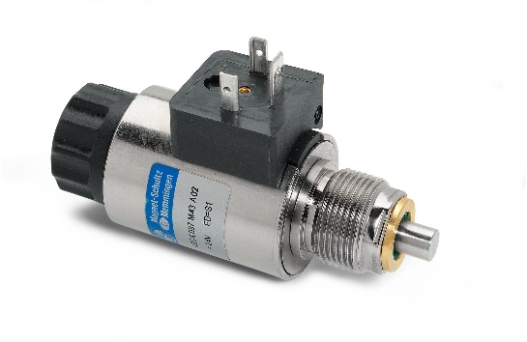 (thumbnail for reference).

**About Magnet Schultz Ltd**

Magnet Schultz Ltd (MSL) is a world leader in the design and development of special-purpose electric locking & holding mechanisms and electromagnet subassemblies. As an astute outsource partner for electromechanical development teams, MSL’s unparalleled knowledge and specialist design expertise helps to eliminate the risk and costs of in-house development projects for bespoke solenoid applications. MSL offers a unique total service that extends from concept to tested prototype to production manufacture. Award-winning actuator products, innovative solenoid solutions and custom-designed subassemblies are used across a dozen market sectors including security, marine, transport, buildings, fire and access control. As the UK arm of the Magnet-Schultz Group, the world’s leading solenoid manufacturer, MSL also supplies a wide range of solenoids and electromechanical accessory parts.

|  |  |
| --- | --- |
| **MSL Company Contact** | **Swordfish Marketing Contact** |
| **Tim Lloyd** Sales Executive Magnet Schultz Ltd 3-4 Capital Park Old Woking Surrey GU22 9LD | **Tina Gagg** Senior Account Manager Swordfish Marketing First Floor 10 King’s Head Place  Market Harborough LE16 7JT |
| [t] +44 (0)1483 794700  [e] [tlloyd@magnetschultz.co.uk](mailto:tlloyd@magnetschultz.co.uk)  [w] [www.magnetschultz.co.uk](http://www.magnetschultz.co.uk) | [t] +44 (0)1858 437743  [e] [tinag@swordfish-marketing.com](mailto:tinag@swordfish-marketing.com)  [w] [www.swordfish-marketing.com](http://www.swordfish-marketing.com) |